**Aim:** To Understand Continuous monitoring and Installation and configuration of Nagios Core.

**Screenshots:**

* Create a EC2 instance and select Ubuntu Server.

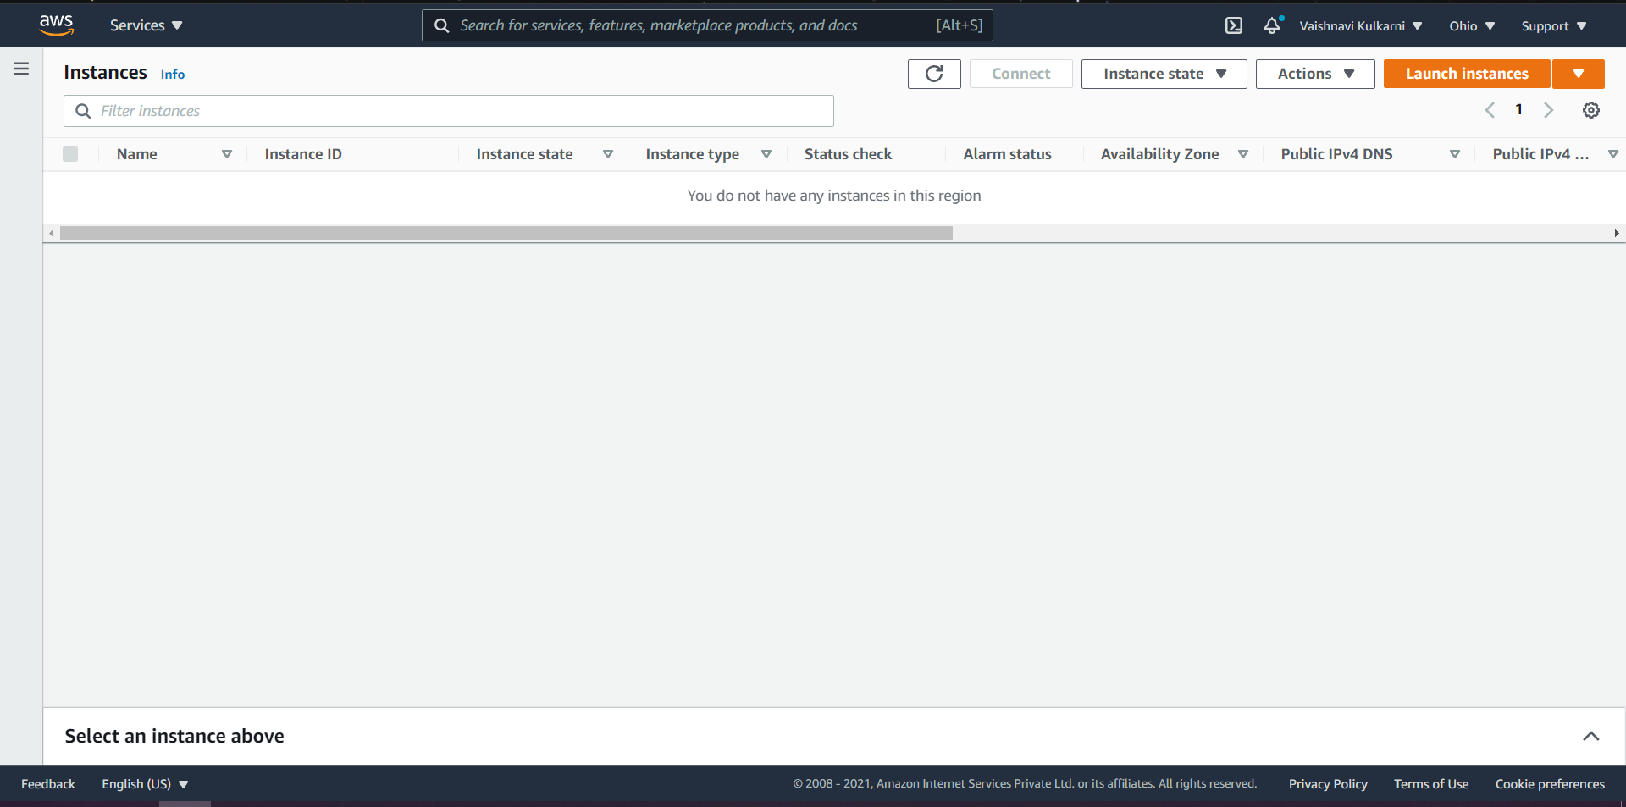

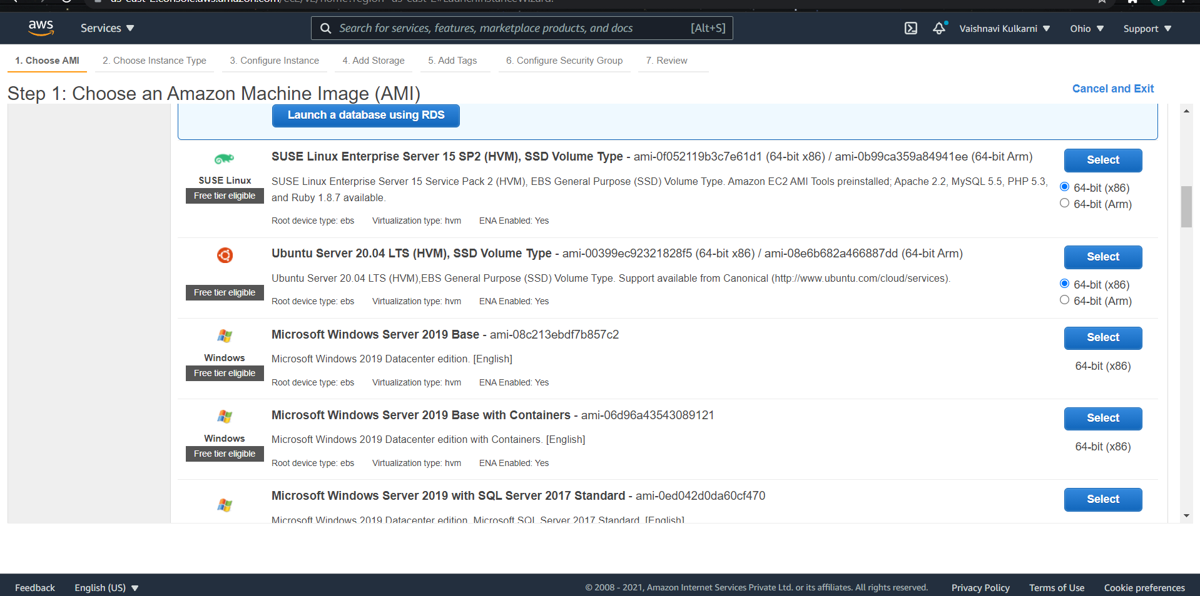

Ubuntu Server 20.04

Click on review and launch

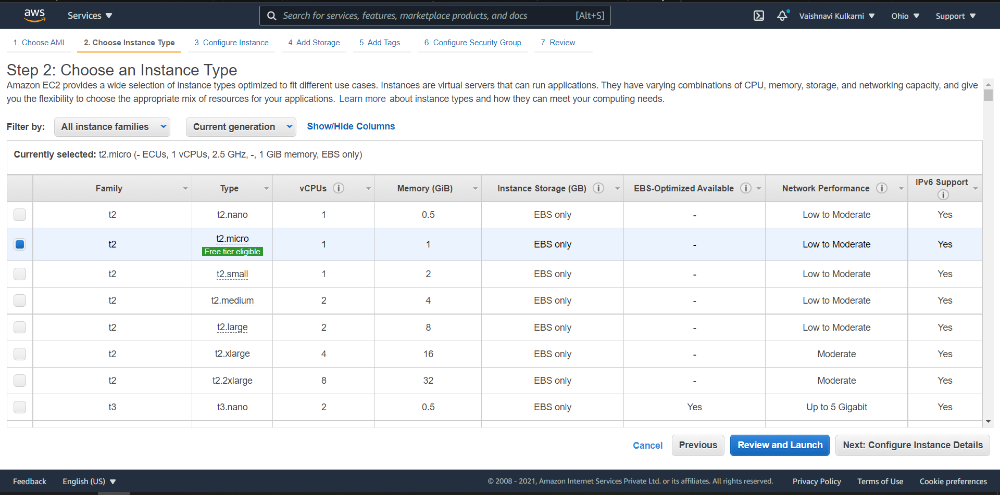

Click on Lunch button to initiate the EC2 instance

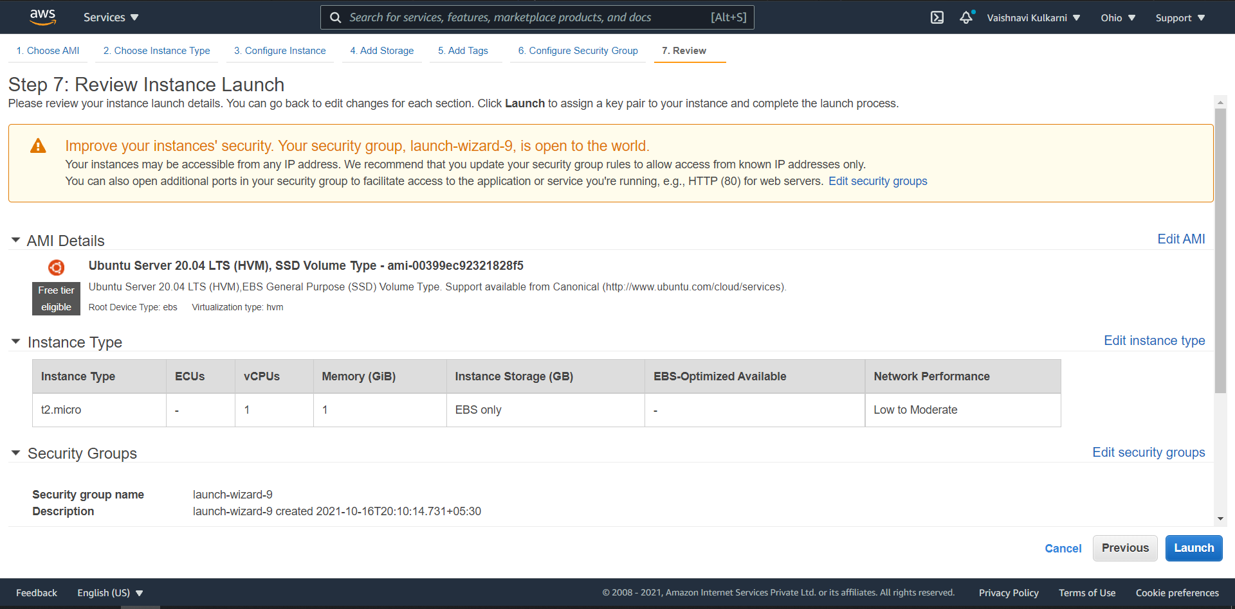

EC2 Instance created

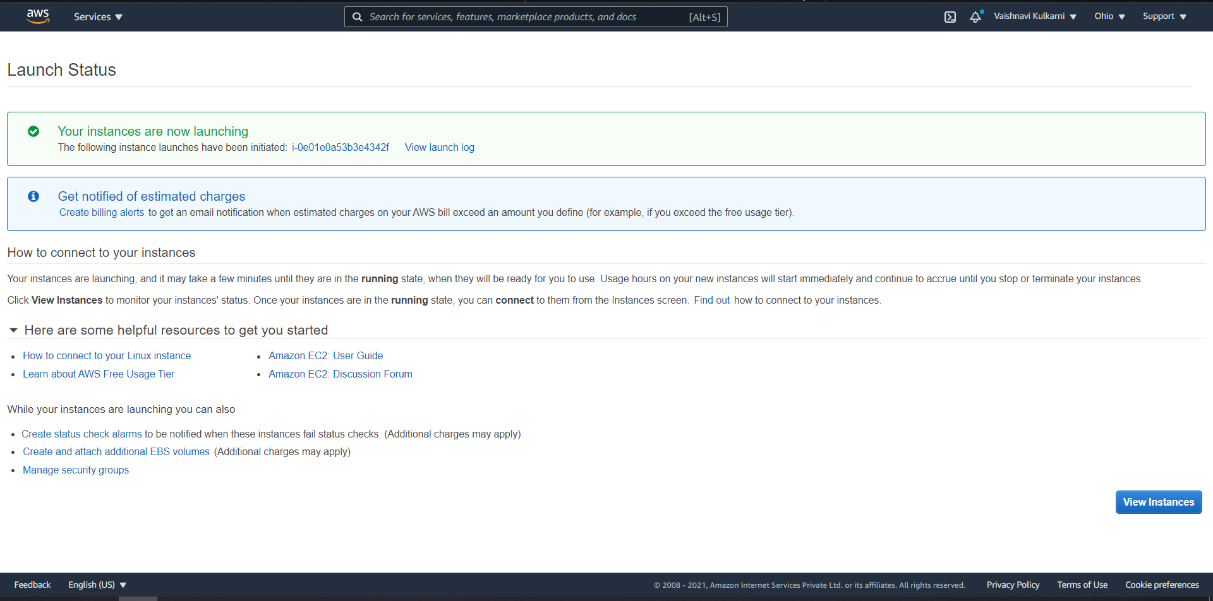

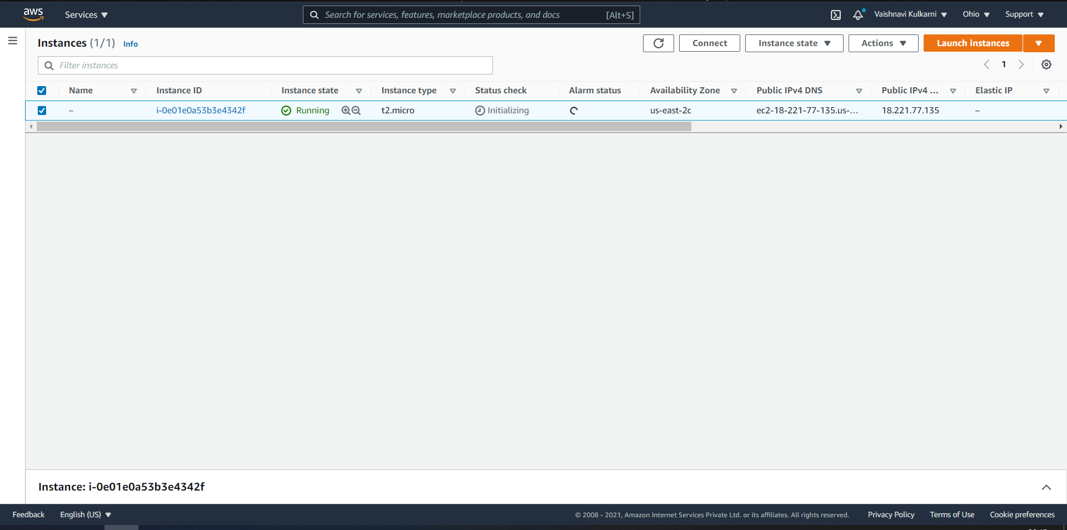

Now, open the instance and click on connect button

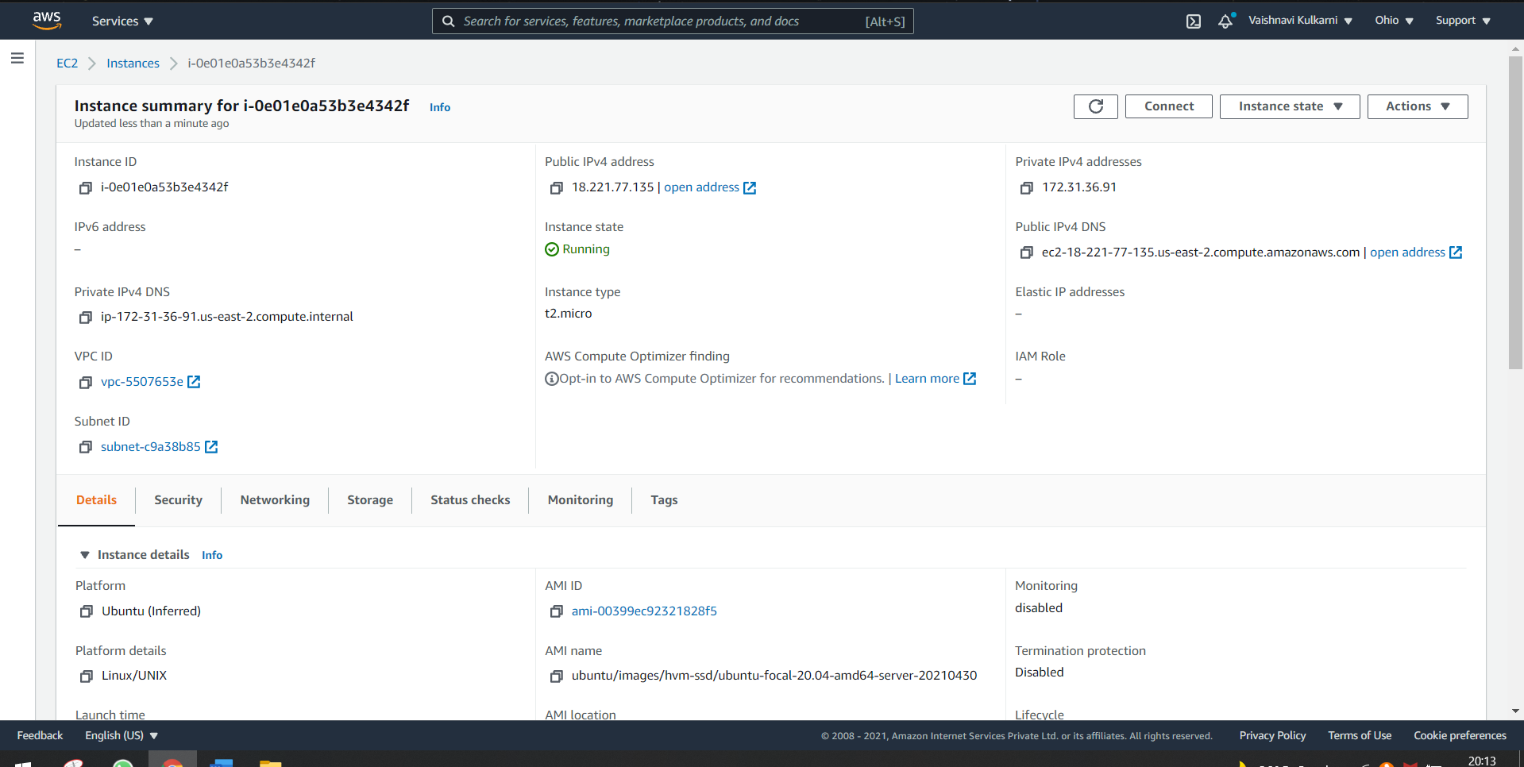

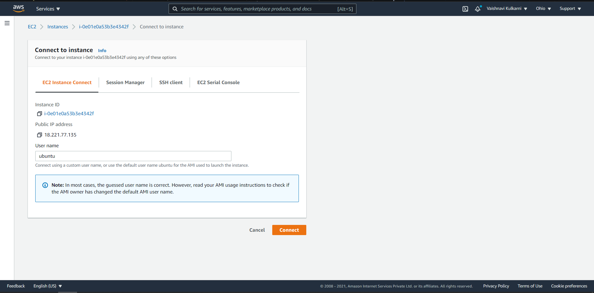

Command prompt of Ubuntu through EC2 instance will get opened

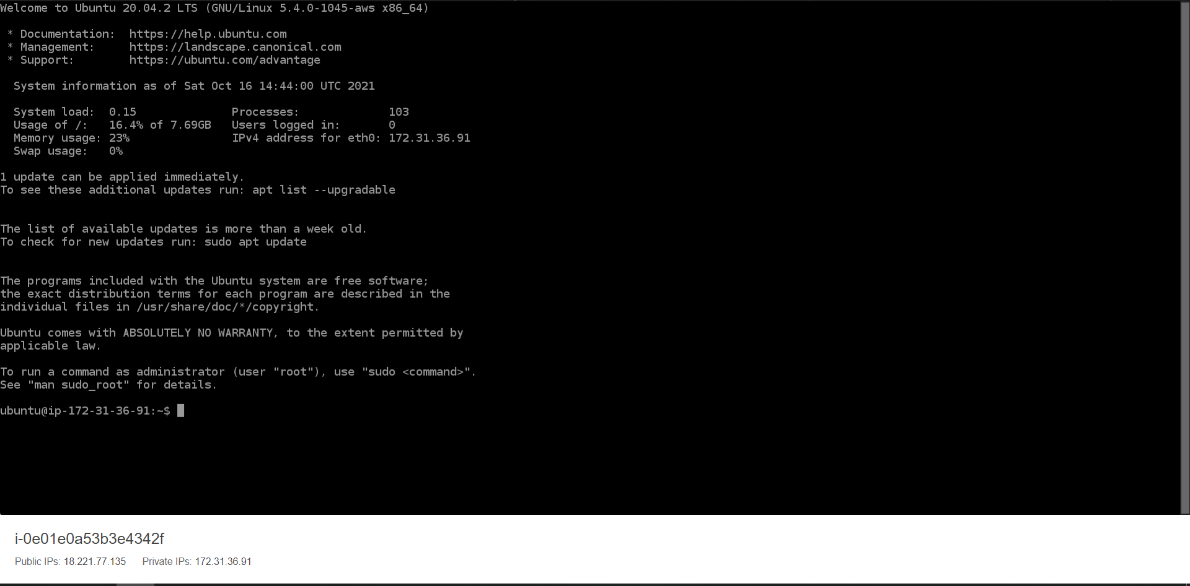

Steps to Install Nagios on Ubuntu 18.04

1. Update the repositories

Command: sudo apt update && apt upgrade

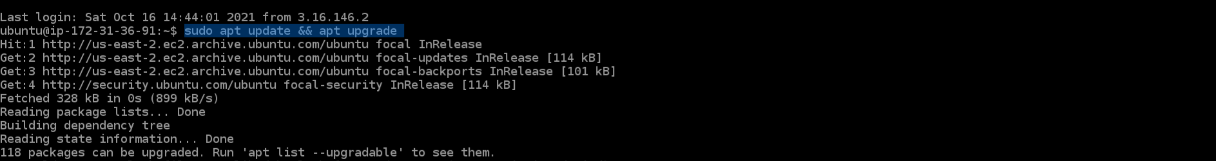

1. Install the LAMP stack

Command: sudo apt-get install -y autoconf gcc libc6 make wget unzip apache2 php libapache2-mod-php7.2 libgd-dev

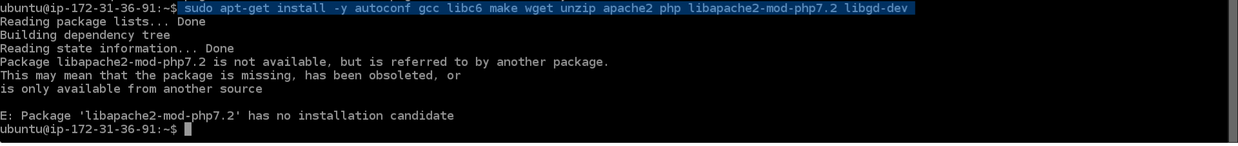

1. Install Nagios Package

Command: cd/tmp

wget -O nagioscore.tar.gz https://github.com/NagiosEnterprises/nagioscore/archive/nagios-4.4.5.tar.gz

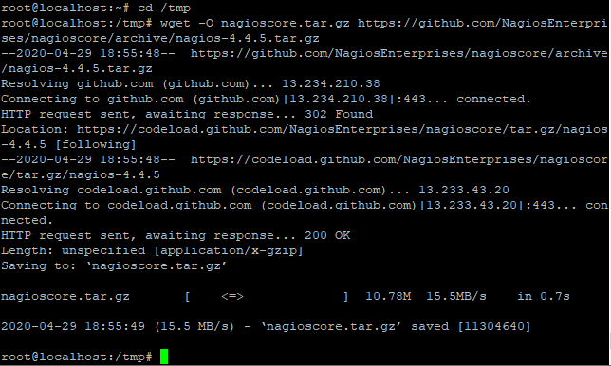

1. Compile the package

cd/tmp/nagioscore-nagios-4.4.5/

sudo./configure--with-httpd-conf=/etc/apache2/sites-enabled

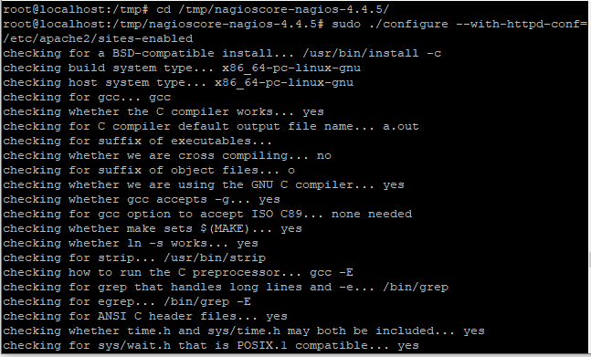

The next step is to build nagios using the make command. Type the following in the terminal

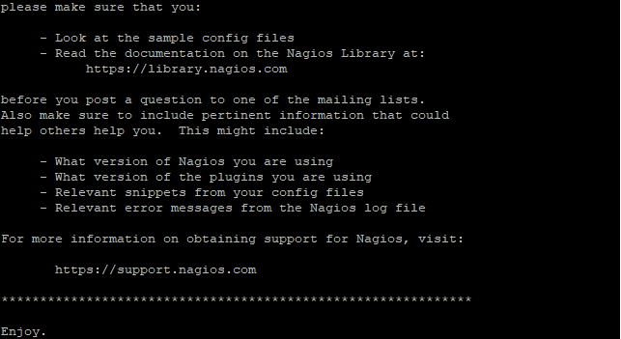

1. Create a group and a user

Command: sudo useradd nagios

sudo groupadd nagios

sudo usermod -a -G nagios www-data

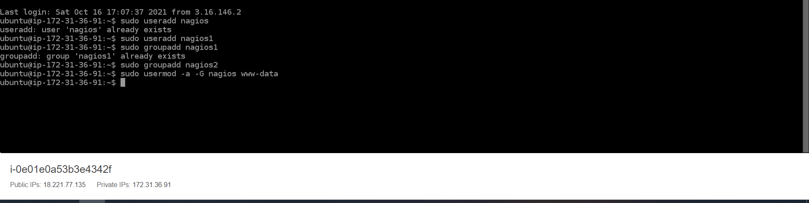

1. Install the Binary files

sudo make install

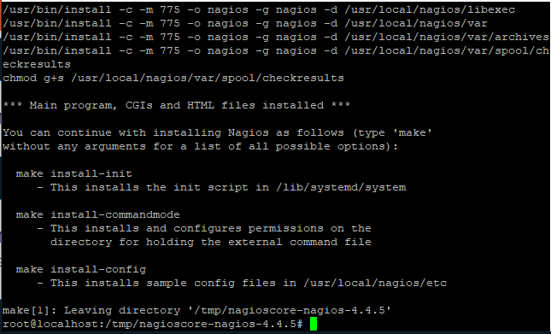

1. Create the systemd unit file

sudo make install-daemoninit

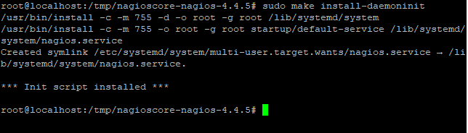

1. Install the external command file

sudo make install-commandmode

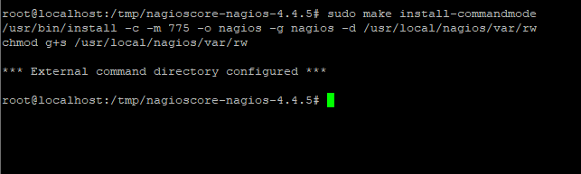

1. Install configuration files

sudo make install-config

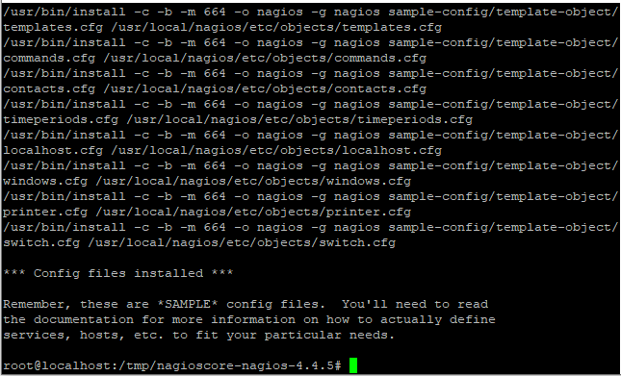

1. Install Apache configuration files

sudo make install-webconf

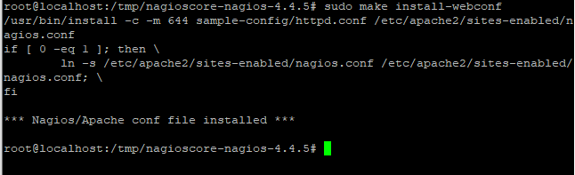

If the Apache rewrite and CGI is not enabled, use the following command to do so.

sudo a2enmod rewrite

sudo a2enmod cgi

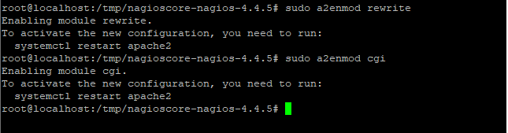

1. Firewall configuration

sudo ufw allow 'Apache'

sudo ufw reload

OR

sudo ufw allow 80/tcp

sudo ufw reload

1. How to Secure Nagios Installation?

sudo htpasswd -c /usr/local/nagios/etc/htpasswd.users nagiosadmin

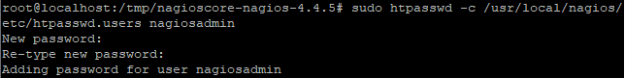

1. Restart the Apache service

sudo systemctl restart apache2.service

sudo systemctl status apache2.service

Starting Nagios and Installing Plugins

sudo systemctl status nagios.service

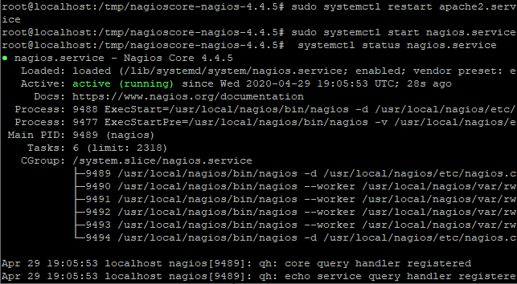

1. Install the Nagios plugins

cd/tmp

wget --no-check-certificate -O nagios-plugins.tar.gz https://github.com/nagios-plugins/nagios-plugins/archive/release-2.2.1.tar.gz

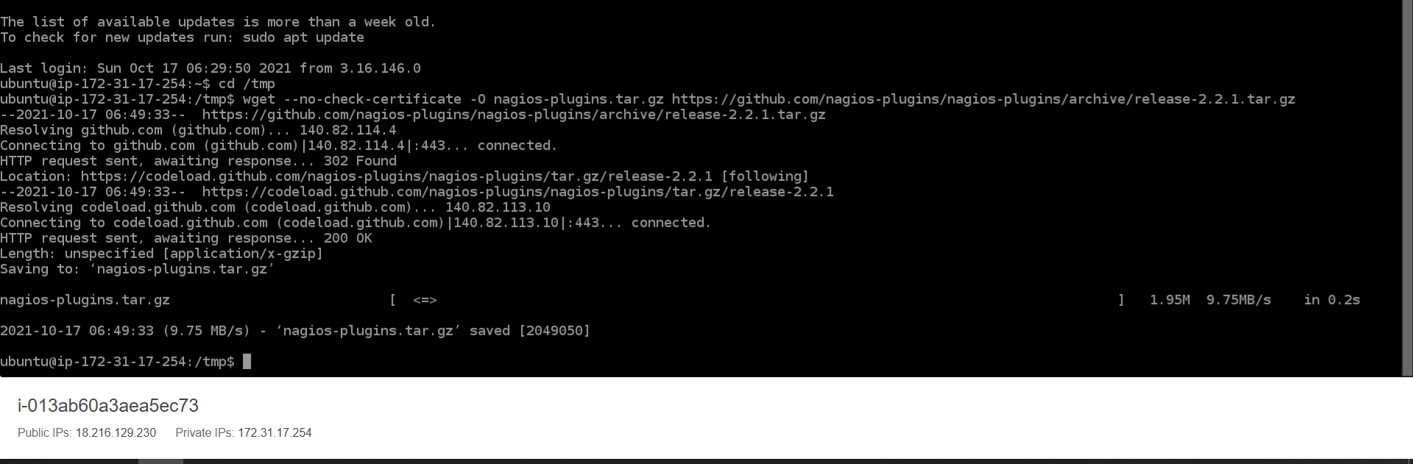

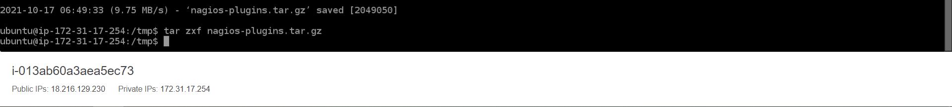

1. Compile the plugins

cd/tmp/nagios-plugins-release-2.2.1/

sudo./tools/setup

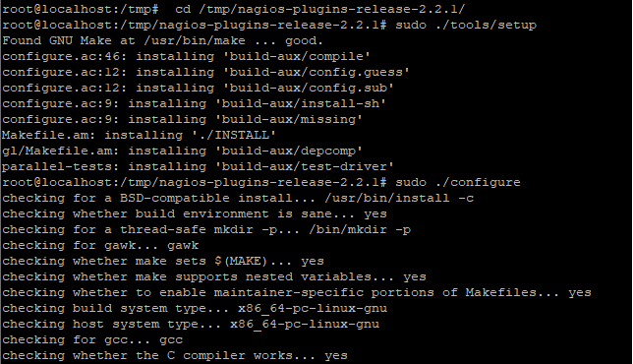

1. Install the plugins

sudo make

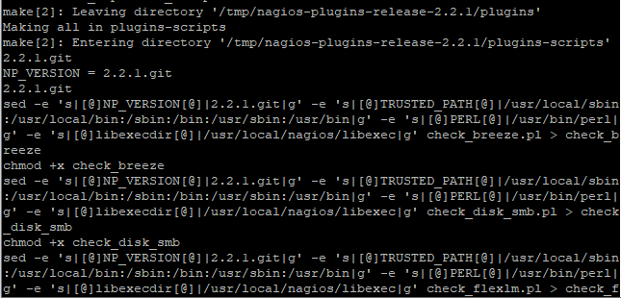

sudo make install

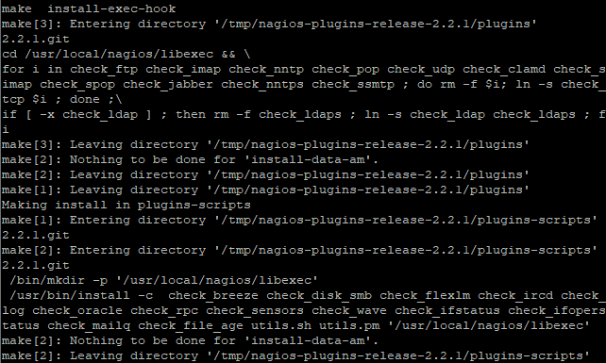

View the Nagios Web Interface

<http://IP_ADDRESS/nagios>

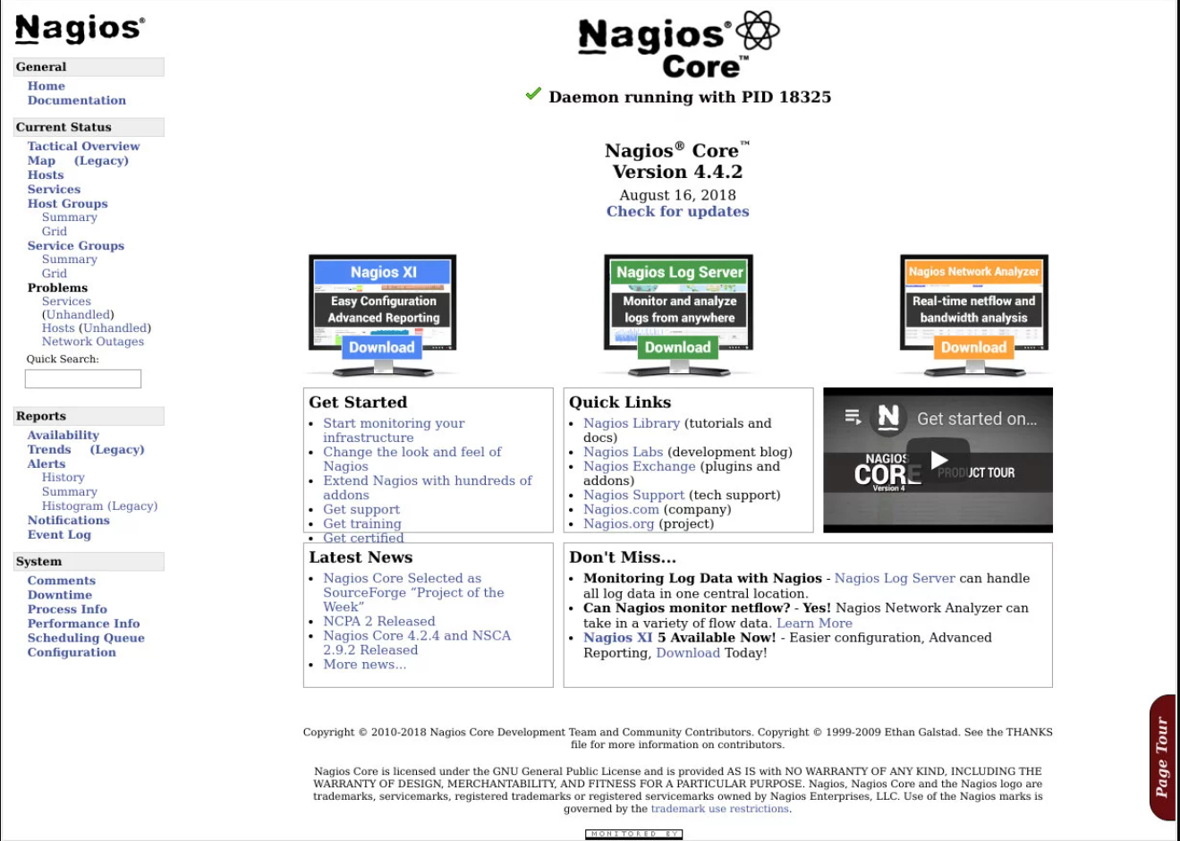

**Conclusion:**

We have successfully installed the monitoring tool with its plugins. I hope the concept is cleared. If you still face any issue, do let us know in the comment section.

**Lab Outcome:** **ITL504.5**

Use Continuous Monitoring Tools to resolve any system errors (low memory, unreachable server etc.) before they have any negative impact on the business productivity.